South Island RAG Rally Registration
Collingwood Holiday Park
William Street, Collingwood 7073
Friday 19 – Sunday 21 NOVEMBER 2021
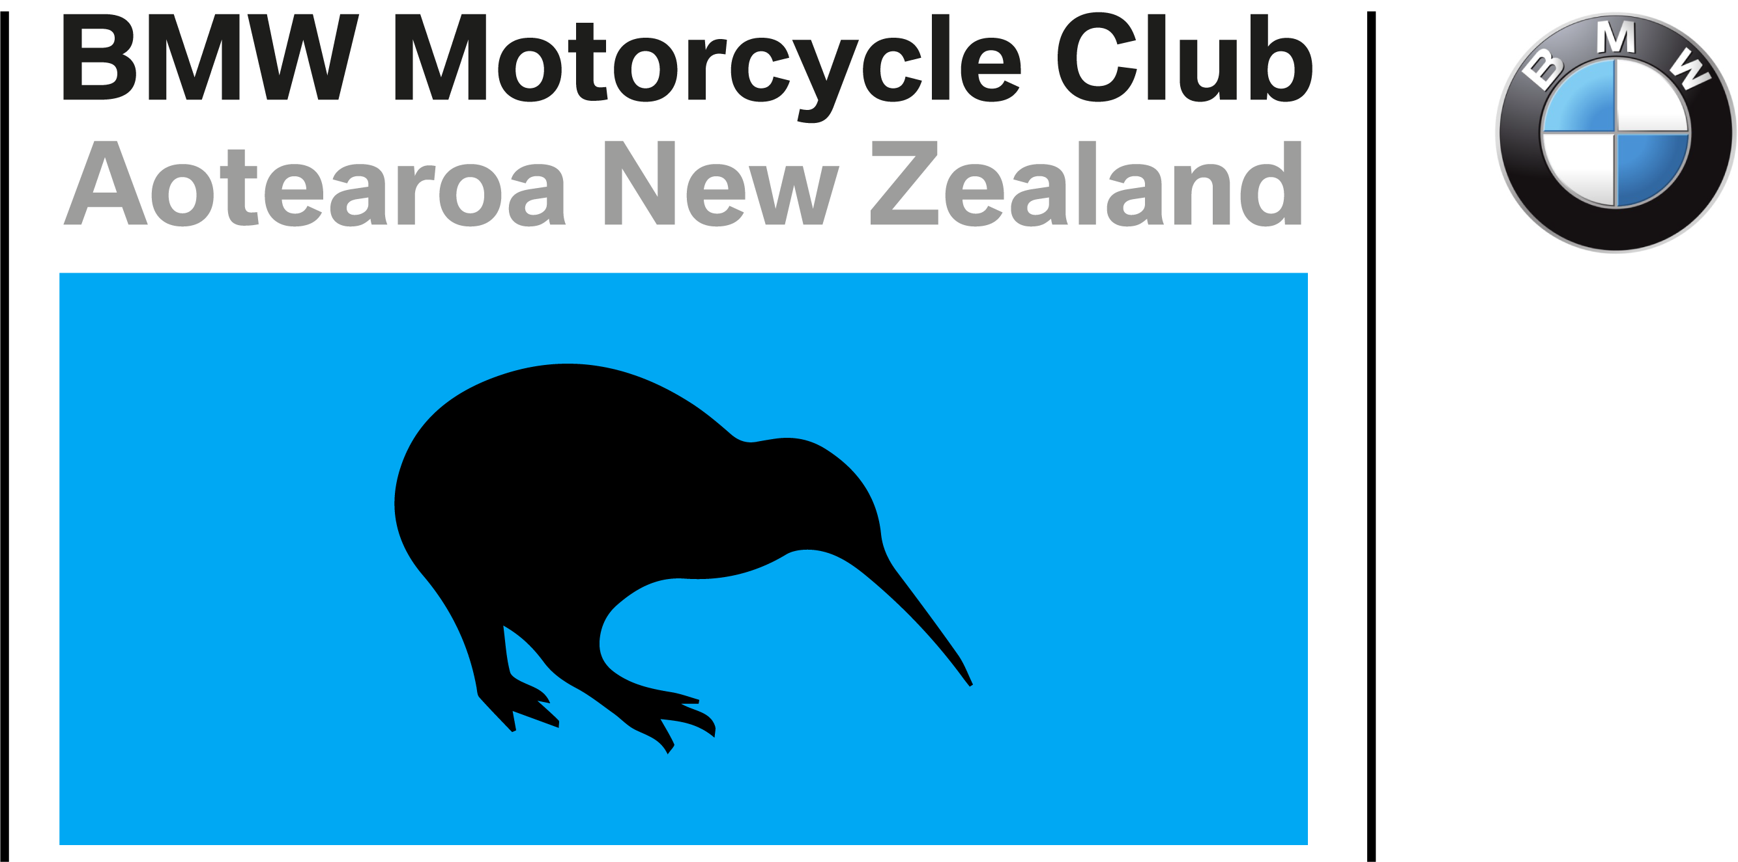

Name
Address
 |  |  | Postcode:
Contacts | Mobile: |  | Phone:
 | Email:
Membership #: |  | Area:
Name 1:  Name 2: |  | # people | Cost PP | Total
Registration: Weekend Participation (includes two nights, Cabin accommodation Friday & Saturday. Breakfast, Saturday and Sunday morning. Dinner Saturday Night @ Collingwood Tavern) |  |  | $135
Rally Participation including Breakfast & Dinner (as above)  - Excludes Accommodation |  |  | $60
Tent Site / per head |  |  | $30
Surcharge for Non-Club members |  |  | $40
TOTAL |  |  |  | $

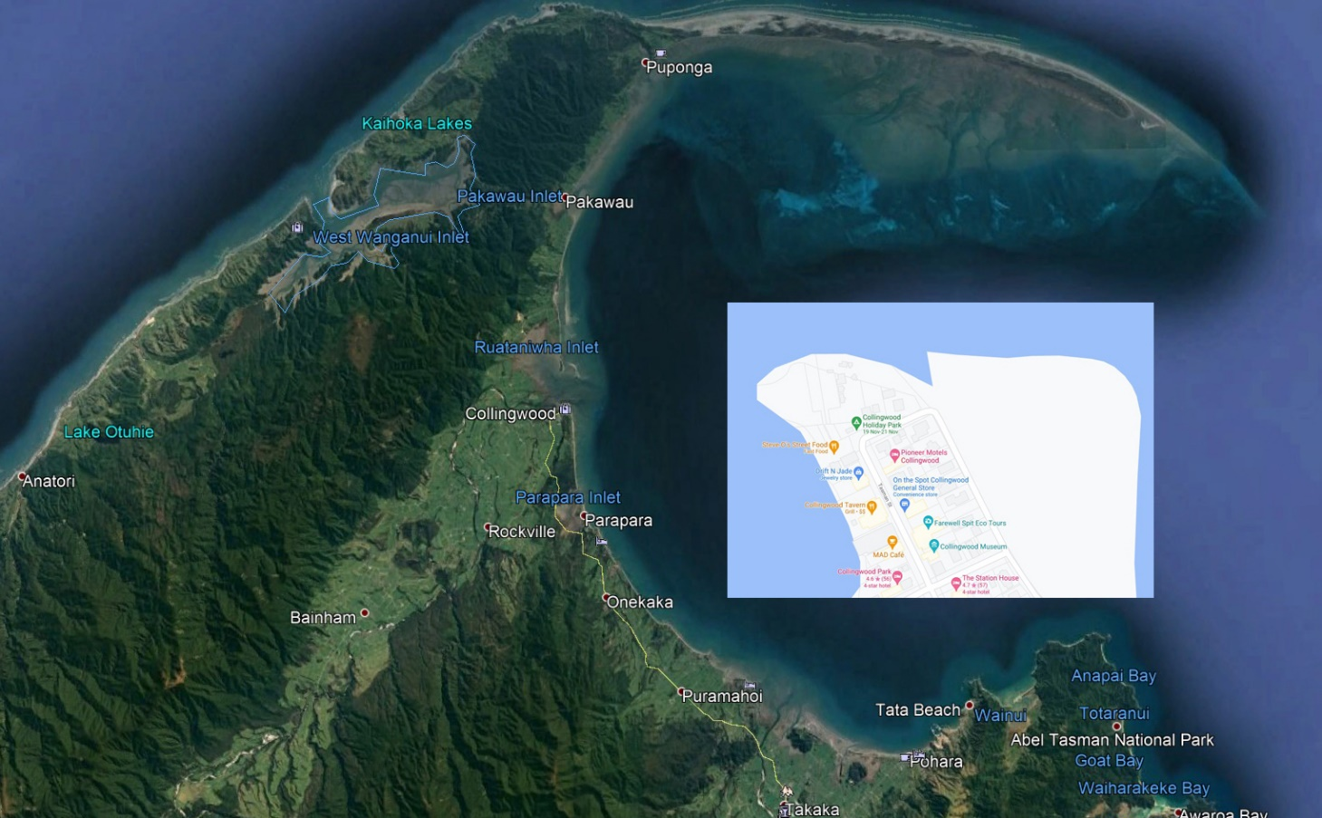
Disclaimer: This event is run under the BMWMCNZ Risk Management Plan as noted in the Club’s newsletter. By registering for this event, participants agree to abide by all the conditions set out in the risk management plan.

Collingwood is situated at the end of SH60 Takaka Golden Bay. A unique region full of places to explore. The Golden Sands of Totaranui. The everchanging Farewell Spit. Venture all the way to Anatori taking you along the Whanganui Inlet. Head south to the Cobb Dam. Stay longer if you wish and enjoy the locality in more detail.
Registration forms: Email to ragsouth@bmwmc.nz (Entries will be acknowledged)
Internet banking payment to BMWMCNZ Event account 03 1519 0034447 001
Please reference with Name, Membership Number and SIRAG

