APPROVED MINUTES

of the meeting of the BMWOR Board held at the Miramar
Golf Course on Saturday 20th March 2021 at 9-00am

Present: Garry Williams, Chris Souness, Colin Gates, Barry Petherick, Phil King and Dave Ross
Start time: 0850

CARRY OVER ACTION POINTS from Board Meeting 6 December 2020
01 | Updated Introductory Package to be sent out to each dealer | Chris Souness | WIP
02 | Any items of interest re the President’s report please send to Garry | All | Done
03 | Consider suggestions for a re-purposed GS Relay Baton as an Award | All | Done
04 | New Board Members needed. | All | Done

- Welcome - introductions to and from new Board members
- Financial Report (Colin Gates – Treasurer)
I am pleased to present to the Board meeting held 20th March 2021 the following report outlining the financial position of our organisation as of 28th February 2021.
1. Current and Investment accounts – Balance as at 26/02/2021:
Westpac - Main: $ 14,760
Westpac - Event account: $ 12,377
TSB Term Deposits:
0001 0.80% Matures 26/07/2021. (Westpac) $10,000
0002 1.30% Matures 01/03/2021. (Westpac) $ 5,168
Total Invested $15,168 $ 15,168

Total funds as at 28/02/2021 $ 42,305

2. Current financial matters:
Operating A/c
Income:
This month includes -
$2,856 - Subscriptions.
$3,000 - Aon sponsorship.
Expenses:
Just regular monthly operating costs.

3. Event Account:
2021 National Rally – To date - Registrations etc. $10,202. Expenses $12,807
2021 NI RAG – Taylor Lodge booked and deposit of $135 paid. Registrations to date $615

4. Term Deposit Maturities:
I will assess cash flow position near the maturity times with regard to re-investment.

5. Challenge
Consideration to be given to the poor rate of return of money held in deposit, subject to the constitution.

I table this report and move that it be accepted as a true and correct record of the current financial position of the Register as of 28th February 2021 and that accounts paid/to be paid since last Board meeting be ratified.

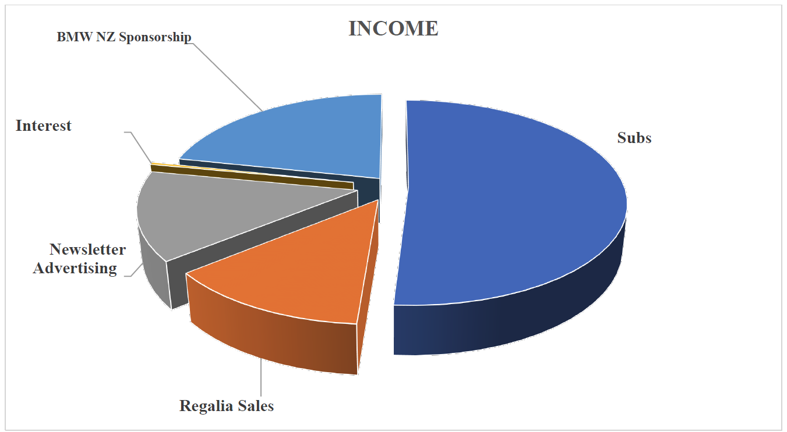
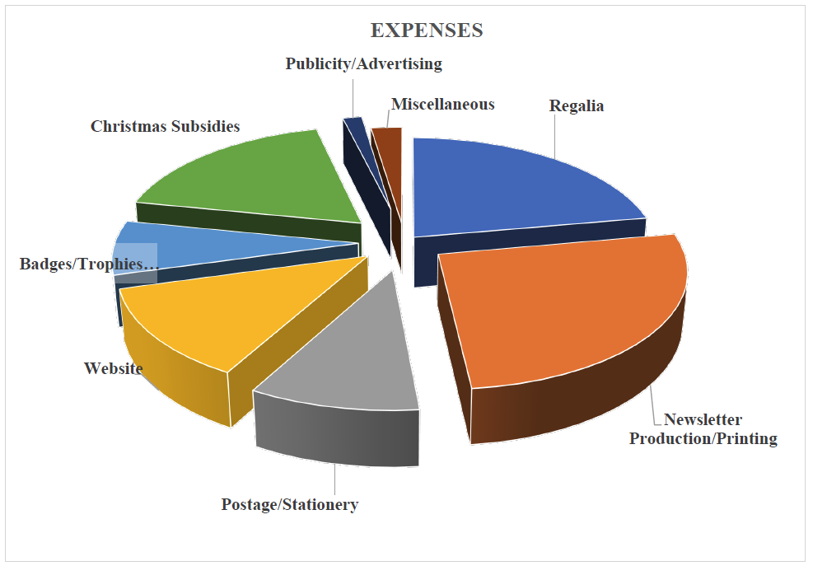
- Strategy Refresher. (Garry Williams – President))
A review of the 2019 – 2021 Strategy Plan to brief the new Board Members up to date of what was previously done and what has been achieved. Created as a ‘Plan on a Page’. Work is now required on a 2021 – 2023 Strategy Place
Action Point: Send a copy of the current Strategic plan (ppt) to all Board Members (Dave Ross)
General Business
- RALLIES
  - Rally 2021 – debrief
    - Overall assessed as Very Good.
    - Good: Value for money of the accommodation and site.
    - Bad: Road riding standards of some attendees.
Cost of Hotel with the added extra perhaps not well advertised
Additional persons on Sunday who did not pay for meals.
Gymkhana time was too rushed. Need for more time in future rallies
    - ? Is there a need for a Feedback Loop? Web or paper based?
  - Rally 2022 – Planning
    - Booked for Methven Lodge 21 – 24 January 2022.
    - Pricing deal worked out that includes breakfast
    - Three GS Rides planned. Road Rides and self-led rides also planned.
    - Working on the Registration Forms and information will be available shortly via the Website and Newsletter.
  - Rally 2023 – Planning
    - Location: Based in Rotorua
    - Rationale: Better availability of site and accommodation
    - Dates: To be advised
    - Committee: Already Created.
    - Member Riding Skills enhancement program.
    - Theme: ‘Depart a better Rider than when you arrived’
  - RAG Rallies:
    - North Island Update
      - Robin Wood handing over to Chris Souness. President and Vice President organised one RAG Rally each.
      - Taylor Lodge has 47 booked
      - ‘Retired and Gentile’ Chalet have 24 booked but not all are going to the dinner.
      - Registrations have closed
    - South Island Planning
      - The ‘Top of the South’ (Peter Brandon) has accepted the organisation of the SI RAG.
      - Date TBA but either side of Labour Weekend.
      - Location being investigated.
      - Information will be available asap.

- Area Reps Meeting .
  - Probable date: 12 & 13 June 2021
  - Location: Brentwood Hotel, Wellington
  - Theme: Strategy
Action Point: Confirm dates with Brentwood & book (Dave Ross)
Action Point: Initial advice and later confirmation to Area Reps (Phil King)

- Policy reviews
  - List of current Policies displayed. Most were reviewed in 2020
  - Need for an updated Policy re Privacy.
  - Need to re-create the Policy for Incident Reporting Form.
  - Need a policy for Ride Reporting.
Action Point: Create Privacy Policy re new legislation (Garry Williams)
Action Point: Update Incident Reporting Policy (Dave Ross)
Action Point: Check the Ride Reporting template in Dropbox (Dave Ross)

- Area review:
  - Terms of reference
  - Regional naming conventions
  - Geographic area/regional reconsideration
Matter deferred to the Next Meeting as work is currently being done by Grant Aislabie

- Completing the change from BMWOR to BMWMC – what’s left?
  - All documents on the Website have been checked and amended.
  - Occasion mention to ‘The Register’ found on the Website and changed.
Action Point: Recheck downloads and Website (Dave Ross)
Action Point: Update photo for Admin on Group Facebook Page (Garry Williams)

- External Marketing and Communication
  - Consistent email signature configuration & application of new logo
Action Point: To supply the required Email signature block to Board and Area Reps (Chris Souness)
Action Point: Talk with IT Phil re creating a signature block for phones (Chris Souness)
  - Dealership / Introductory members. Nothing being received.
    - Discussion on how the current system with the dealers is not working.
    - There should be a Relationship Portfolio for them.
    - Discuss the creation of an A5 ‘zip lock’ bag containing (see list below) for Dealers to hand out with BMW Motorcycle Sales (New or Used).
      - President’s Message
      - AON, Bluebridge and InterIslander information
      - Key ring? Pen? Fridge Magnet?
      - Local Area Rep Business Card
      - AON Snips (Micro Adverts)
(To discuss with Dealer’s via Relationship Portfolio prior to actioning.)
    - Posters supplied to Area Reps as requested. They are working very well in dealer premises.
Action Point: Relationship Portfolio to be held by Vice President (Chris Souness)
Action Point: Costings re Key rings, Pens, Fridge Magnets (Dave Ross)
Action Point: Looking at creating ‘zip lock’ bags welcoming pack (Chris Souness & Phil King)
Action Point: Investigate having links to Dealers on our Website (Dave Ross)

  - Membership collateral (review Welcome pack, etc.)
    - See points above
  - Membership benefits enhancement, Accommodation, parts and accessories.
    - Interest in trying to access / locate additional benefits for members
Action Point: Access / Locate additional Member benefits (Chris Souness and Phil King)
  - Recruitment. New and renewing member pitch pack.
    - Could the A5 ‘zip lock’ bags also be supplied t Area Reps? Future discussion point.
  - New logo – Clubs International / Roll out
    - BMW AG has given our club until the end of the year to change to the new logo as we had only just undergone a complete new approved logo process. We are well underway and will be completed before them. Other club’s has to change straight away.
    - Discussion re how the Black Kiwi sort of disappears with the new BMW Blue in the logo. Change the Kiwi to white to see the difference.
Action Point: Create a test Logo using a white Kiwi (Chris Souness)

- Roles and Responsibilities (Shared work load)
  - Roles discussed and most are clearly identified.
  - Vice President is available for additional project work.
  - Member Rep discussed and advises that he sees his role as the contact point between Club Members and the Board via the Area Reps. He will work with the Area Rep and information to go to them should now go to Member Rep.

- Webmaster / IT role
  - Website updates (description of events, trophies, etc. – what do new members need to know?
  - 40th Anniversary GS Trophy – Best GS Photograph. Details being working on?
  - Website is updated on a regular basis by Dave Ross, Major updates are contracted to Nettl.
  - Changes required to ‘Gallery’. Once you click on it you cannot click back to the Website.
  - Gallery Photos are historical Canterbury Photos and that needs to change.
  - Can a single point email with multiple receivers be created on our email system?
Action Point: Look to delete the current ‘Gallery’ and replace it with ‘Photos’. (Dave Ross)
Action Point: Check with IT Phil re single email for multiple receivers. (Dave Ross)

- Club Apparel.
  - Initial swatch shown to Board re available club clothing. Work in Progress as the Roundel is wrong.
  - System for ordering clothing via our ‘Shop’ explained.
  - Phil King advises that Ian Macartney has access to a new printing system for clothing.

- Newsletter.
  - Phil King advises that he had been approached by several people at the Rally complaining that they wanted a printed copy of the newsletter.
  - The club cannot go back into the Printing, Packing and posting of Newsletter as the costs to far to great. Costs savings from going digital are put back into the club.
  - The system for supplying printed copies via the Area Rep was explained.
  - Discussion on current Newsletter production and that the quality is not particularly good. Newsletter Versions now need to be in High Resolution.
  - Is Nettl still the right company to create the Newsletter? The current layout and gaps on some pages is terrible.
  - Another discussion on using ISSUU or Joomag.
Action Point: Have Newsletter supplied in High Resolution (Dave Ross)

- Additional Item.
  - Phil King presents an email forwarded to him from the ‘Top of the South’ Area Rep. The email originated from one of that area’s members.
  - Discussed ‘in committee’.
  - A formal response will be prepared by the President and Chair of the Board. The reply will be formally sent from the Secretary on behalf of the Board.
  - The Issue is one that has been raised publically and has also been published in the Newsletter. A discussion took place about published both the request and the response so as to fairly balance the question.
Action Point: Create Formal Response to the request received (Garry Williams)

There being no further business, the meeting was closed at 1500

ACTION POINTS:
01 | Send a copy of the current Strategic plan (ppt) to all Board Members | Dave Ross | Done
02 | Confirm dates for Area Reps Meeting with Brentwood & book | Dave Ross | Done
03 | Initial advice and later confirmation of meeting dates to Area Reps | Phil King
04 | Create Privacy Policy re new legislation | Garry Williams
05 | Update Incident Reporting Policy | Dave Ross
06 | Check the Ride Reporting template in Dropbox | Dave Ross
07 | Recheck downloads and Website re BMWOR | Dave Ross
08 | Update photo for Admin on Group Facebook Page | Garry Williams
09 | To supply the required Email signature block to Board and Area Reps | Chris Souness
10 | Talk with IT Phil regarding creating a signature block for phones | Chris Souness
11 | Relationship Portfolio to be held by Vice President | Chris Souness
12 | Costings re Key rings, Pens and Fridge Magnets | Dave Ross
13 | Looking at creating ‘zip lock’ bags welcoming pack | Chris Souness and Phil King
14 | Investigate having links to Dealers on our Website | Dave Ross
15 | Access / Locate additional Member benefits | Chris Souness and Phil King
16 | Create a test Logo using a white Kiwi | Chris Souness
17 | Look to delete the current ‘Gallery’ and replace it with ‘Photos’. | Dave Ross
18 | Check with IT Phil re single email for multiple receivers. | Dave Ross
19 | Have Newsletter supplied in High Resolution | Dave Ross
20 | Create Formal Response to the request received | Garry Williams

