AWARDS 2021 NATIONAL RALLY – NEW PLYMOUTH
Service Awards
 | 30 year: | Stuart YOUNG – 1016. | Waitakere
 | 20 year: | David ALLEN - 1987 | Auckland
 |  | Snow BUCKTON – 2021 | Kamo
 |  | Cedric CHAMBERS – 2017 | North Short City
 |  | Peter LYNER – 2045 | Tauranga
 |  | David OLDERSHAW – 2052 | Wellington
 |  | Keith McGOWEN – 2055 | Feilding
 |  | Alexander BREIG – 2103 | Christchurch
 | 10 year: | Bruce MELLSOP – 3032 | Napier
 |  | Michael WYLIE – 3051 | Wellington
 |  | Peter BRANDON – 3055 | Blenheim
 |  | Kevin HARRIS – 3070 | Auckland
 |  | Sacha BRANDON – 3575 | Blenheim

Concourse | Rob Hargreaves – 3431 | BMW R100R | 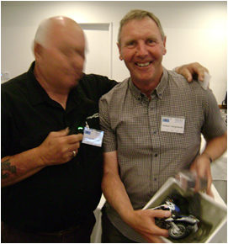
(Runner up) | William Robertson – 2844 | BMW R1200GS 2009 | 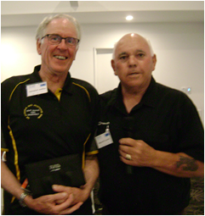

Gun Trophy | Peter Nash – 3184 | For the SAMA series of articles | 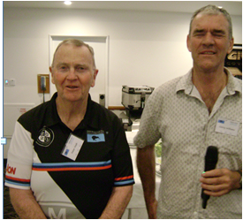

Gymkhana | 1st. Dale Grover – 3170  2nd Rob George – 3483  3rd Chris Harvey – 3945  Graeme Duncan - 3099 | 2 mins 29 seconds  2 mins 45 seconds  2 mins 52 seconds  Highest time penalty | 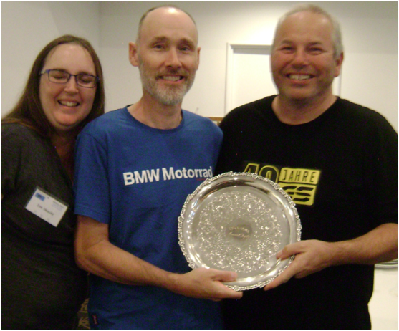

Filthiest Bike | Ben Wilkins - 3854 | BMW R80 GS | 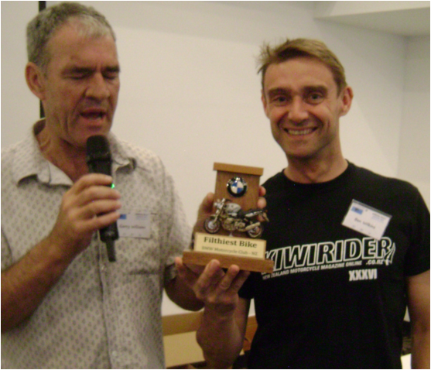

Opps Award | David Fish – 3854 | Mishap trying to reach the ground when parking. | 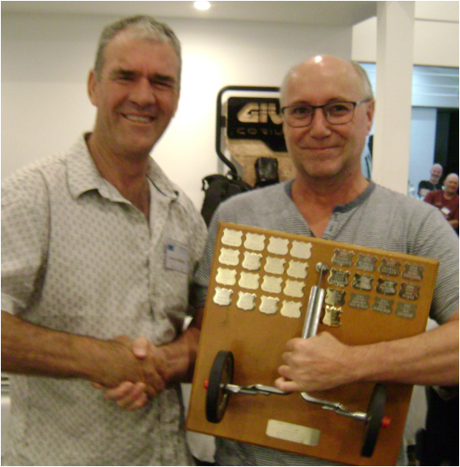

Pillion in a Million | Tania Langen – 3590 |  | 