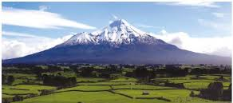
TARANAKI 2021 Annual Rally & AGM
22 – 25 January 2021
Quality Hotel Plymouth International

Other New Plymouth Accommodation Options

Northgate Motor Lodge
16-18 Northgate, Strandon
06 758 5324 - ($123.00 - $130.00)

Lockwood Manor Motel
49 Hobson Street
0508 758 758 - ($130.00 - $145.0)

Novotel New Plymouth
Cnr Hobson and Leach Streets
06 769 9579 - ($210.00 - $235.00)

The Devon
390 Devon Street
06 759 9099 - ($170.00 - $185.00)

The Strand
464 Devon Street
06 759 5324 - ($120.00 - $130.00)
Amber Court Motel
100 Leach Street
06 758 0922 - ($120.00 - $135.00)

Asure Abode Motor Inn
155 Courtenay Street
06 769 5465 - ($120.00 - $135.00)

Ducks & Drake Boutique Hotel & Backpackers
48 Lemon Street
06 758 0404 - ($68.00 - $95.00)

Auto Lodge Motor Inn
393 Devon Street
06 759 9918 - ($120.00 - $130.00)

Is now the time to start planning both
your Ride there and your Accommodation
More Information in next month’s Newsletter 