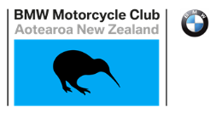 | Rally 2021  Taranaki Update

With New Zealand now approaching something closer to normal it is time to resume your planning for our 2021 Annual Rally.

The Registration Form is now in the Newsletter and will shortly be on the Club’s website. We have an awesome deal on Rally Polo Shirts. These are 100% polyester Sports Polo’s with interlock weave and weight. Material rated 155gsm.

The features are the Grid Mesh underarm panels for breathability, a unique sleeve print feature, contracting panels and piping with a knitted collar with contrast placket.

Please get your order in and paid early to secure one as with the World’s Covid19 situation, supply is limited.
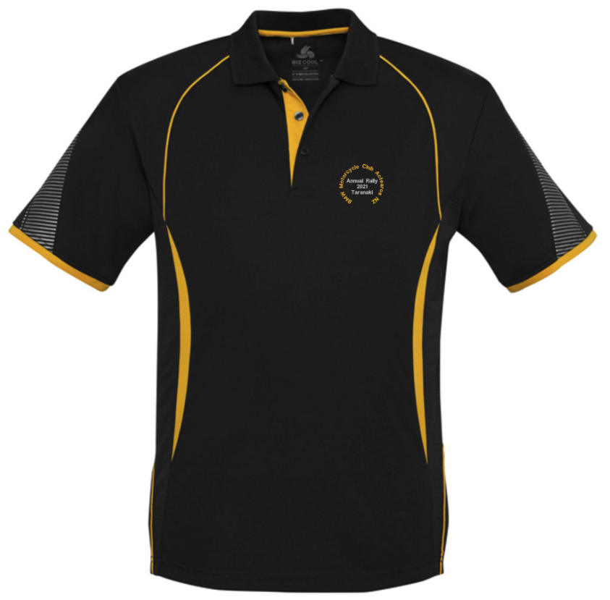

SIZING CHART These sizes are half chest measurements in centimetres
Mens:
S | M | L | XL | 2XL | 3XL | 5XL
52 | 55 | 58 | 62 | 65 | 71 | 79
Womens:
8 | 10 | 12 | 14 | 16 | 18 | 20 | 22 | 24
46.5 | 49 | 51.5 | 54 | 56.5 | 59 | 62 | 65 | 68

The Plymouth Hotel is standing by for your reservations so why not stay on site and be right amongst it. There are Limited Rooms so get in quick and with full breakfasts included, the prices are pretty amazing.
If you’d rather save a couple of dollars, check out the other options in the Newsletter for Hotels, Motels, Cabin or Camp Sites.
There are lots to do here, lots to see and plenty of great riding to keep you occupied.
We look forward to greeting you all in January.
Ray Senior – Taranaki Area Rep.

