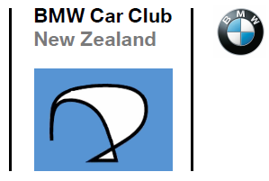
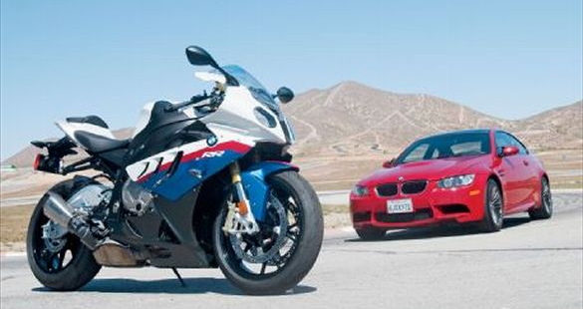
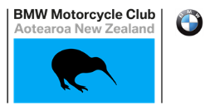

NATIONAL BMW FESTIVAL
Saturday 21st & Sunday 22nd March 2020
Braxmere Lodge, 88 Waihi Rd, Tokaanu
Registration Details
( ) Yes, I/we would love to join you at the 2020 National BMW Festival
Name (s)

Car/Bike Model

Car/Bike Year

Car Bike Registration number

Number attending Saturday dinner
($65pp)
Number for Saturday night shuttle

Pickup address for shuttle

Number attending Sunday brunch
($20pp)
Contact phone number

Please return to Gerry Hodges (BMW Car Club NZ) at president@bmwclub.co.nz by Saturday 29th February to reserve your place.
Queries to:
BMW Car Club NZ: Gerry Hodges - 0274 925 040
BMW Motorcycle Club: Garry Williams - 027 242 7799 or Steve Parkinson – 021 989 092

