BMW OWNERS REGISTER  INITIAL INFORMATION SHEET | 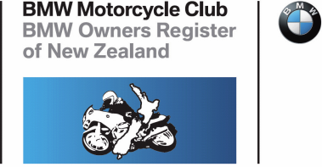

Type of Membership: PILLION

Name
Year of Birth
Address
City |  |  | Post Code
Email
Phone/s

Who do you Pillion with |  | Member Number
Original joining date

Signature |  | Date

You can read the Club’s Privacy Statement by clicking: https://www.bmwor.org.nz/resources/

EMAIL TO: membership@bmwor.org.nz

